PRODUCT PROFILE

FOR

MEAT (HS O2)

Prepared by
Research & Innovation Directorate
Kenya Export Promotion and Branding Agency
(KEPROBA)

AUGUST 2026

Contents
1.0 Background 4
2.0 Global Meat Sector 7
3.0 Kenya’s Meat Exports and Imports Market trends 13
3.1 Export Potential 20
4.0 Competitor Analysis for Kenya’s top 5 Export Markets for Meat 24
5.0 Policy Recommendations 25
References 26
List of Tables
Table 1: Global Exports of meat products by top 25 countries 7
Table 2: Global exports of meat products by values 8
Table 3: Global exports of meat products by quantity (tonnes) 9
Table 4: Global Imports of meat products by top 25 countries 10
Table 5: Global imports of meat product by values 11
Table 6: Global imports of meat products by quantity (tonnes) 12
Table 7: Kenya's exports of meat products by country 14
Table 8: Kenya's exports of meat products by values 15
Table 9: Kenya's exports of meat products by quantities (tonnes) 16
Table 10: Kenya's imports of meat products by country 17
Table 11: Kenya's imports of meat products by values 18
Table 12: Kenya's imports of meat products by quantities (tonnes) 19
Table 13: Competitor Analysis 24

List of Figures
Figure 1: Per capita meat consumption by income group and meat type 4
Figure 2: Situational analysis of international trade of Meat products 6
Figure 3: Export potential of meat (except poultry) 20
Figure 4: Export potential for swine meat, cured, n.e.s. 21
Figure 5: Export potential for Processed meat 22
Figure 6: Export potential of Meat (poultry) 23

1.0 Background
The global meat market size as of 2025 was valued at USD 1.5 Trillion. IMARC Group (2025) estimates the global meat market may reach USD 1.8 Trillion by 2034, exhibiting a CAGR of 1.95% from 2026-2034. The OECD-FAO Agricultural Outlook 2025-2034 indicates that global meat consumption is a sector that continues to rise that is driven mainly by population growth, urbanization, and rising incomes in middle-income countries. The report projects an annual per capita consumption of meat to increase by 0.9 kg per capita/year edible retail weight equivalent by 2034 (OECD, 2025). Global poultry, sheep meat, beef, and pig meat consumption is projected to grow by roughly 21%, 16%, 13% and 5% respectively by 2034.
Figure 1: Per capita meat consumption by income group and meat type
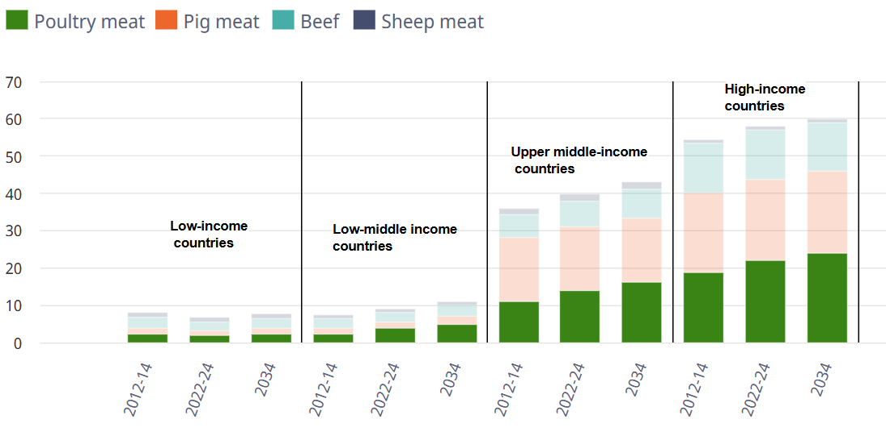
Source: OECD/FAO (2025), ''OECD-FAO Agricultural Outlook'', OECD Agriculture statistics (database)
World meat production is projected to rise 13% or 46 carcass weight equivalents (cwe) to an estimated 406 Mt cwe by 2034. Over half (55%) of the growth in meat production will occur in Asia, led by a 15 Mt increase in poultry production.
The global meat sector is facing increasing pressures on multiple fronts. In recent years, producers worldwide have contended with high input costs, increasingly stringent environmental and animal health regulations, and various disease outbreaks. Feed costs, which spiked in the early 2020s, have since moderated, but other operating and labour expenses continue to rise. In response, the sector is increasingly focused on raising productivity through improved breeding techniques, better herd and flock management and higher slaughter weights. These improvements are essential not only for cost management, but also for enhancing sustainability in the face of competitive pressures from alternative protein sources (OECD, 2025).
For Kenya, the meat sector is one of the most important components of Kenya's livestock industry, contributing significantly to agricultural GDP, employment, food security, and export earnings. The livestock subsector contributes approximately 12% of Kenya's GDP and about 42% of agricultural GDP The sector includes beef, goat meat (chevon), mutton, camel meat, pork, poultry, and processed meat products. According to the KNBS Economic Survey 2026, the Agriculture, Forestry and Fishing sector grew by 3.1% in 2025 and continued to contribute more than one-fifth of Kenya's GDP, with livestock remaining a key component of this growth. The meat and meat products sub-sector grew by 9.8% in 2025 compared to 4.2% growth in 2024. Within this sub-sector, pork processing expanded by 19.2% while the production of sausages and similar products of meat, offal or blood increased by 7.4%. The manufacture of prepared animal feeds expanded by 8.9% in 2025 compared to 6.9% in 2024, while the animal and vegetable fats and oils sub-sector recorded growth of 4.1% up from 2.1% in the previous year.

Figure 2: Situational analysis of international trade of Meat products

Exports
- Meat products exports in 2024 were valued at USD 192.6 billion globally.
- Top global exporters were; Brazil (USD 30.0 billion; 15.6%), USA (USD 21.3 billion; 11.1%), Australia (USD 17.9 billion; 9.3%), Netherlands (USD 13.6 billion; 7.1%) and Spain (USD 11.8 billion; 6.1%).
- Lead exports of meat products by value in 2025 were; Meat of bovine animals, frozen (USD 45.9 billion; 23.8%), Meat of bovine animals, fresh or chilled (USD 40.4 billion; 21.0%).
Imports
- In 2025, the world imports for meat and meat products were valued at USD 189.2 billion and increase by 11.3% from USD 170.0 billion in 2024.
- Lead importers in 2025 include: China (USD 22.8 billion; 13.3%), USA (USD 15.3 billion; 8.9%), Japan (USD 10.4 billion; 6.1%), Germany (USD 8.6 billion; 5.0%) and Mexico (USD 7.7 billion; 4.5%).
- Lead imports of meat products by value in 2025 include: Meat of bovine, frozen (USD 44.2 billion; 23.4%), Meat of bovine animals, fresh or chilled (USD 39.4 billion; 20.8%)

2.0 Global Meat Sector

Table 1: Global Exports of meat products by top 25 countries
Source: International Trade Centre Trade database
- In 2025, global exports for meat and meat products were valued at USD 192.6 billion an increase by 12.7% from USD 170.8 billion in 2024.
- On average, exports grew by 5% between 2021 to 2025.
- Top global exporters were; Brazil (USD 30.0 billion; 15.6%), USA (USD 21.3 billion; 11.1%), Australia (USD 17.9 billion; 9.3%), Netherlands (USD 13.6 billion; 7.1%) and Spain (USD 11.8 billion; 6.1%).

Table 2: Global exports of meat products by values

Source: International Trade Centre Trade database
- Lead exports of meat products by value in 2025 were; Meat of bovine animals, frozen (USD 45.9 billion; 23.8%), Meat of bovine animals, fresh or chilled (USD 40.4 billion; 21.0%), Meat and edible offal of fowls of the species Gallus domesticus, ducks, geese, turkeys (USD 39.2 billion; 20.4%), Meat of swine, fresh, chilled or frozen (USD 37.0 billion; 19.2%) and Meat of sheep or goats, fresh, chilled or frozen (USD 11.3 billion; 5.8%).

Table 3: Global exports of meat products by quantity (tonnes)
Source: International Trade Centre Trade database
- Lead exports of meat products by quantity in 2025 include; Meat and edible offal of fowls of the species Gallus domesticus, ducks, geese, turkeys (17.6 billion tons; 51.2%), Meat of bovine animals, frozen (8.2 billion tons; 24.0%), Edible offal of bovine animals, swine, sheep, goats, horses, asses, mules or hinnies, fresh (5.1 billion tons; 14.8%), Meat of sheep or goats, fresh, chilled or frozen (1.6 billion tons; 4.6%) and Meat and edible offal, salted, in brine, dried or smoked; edible flours and meals of meat (1.0 billion tons; 2.8%).

Table 4: Global Imports of meat products by top 25 countries
Source: International Trade Centre Trade database
- In 2025, the world imports for meat and meat products were valued at USD 189.2 billion and increase by 11.3% from USD 170.0 billion in 2024.
- Between 2021 and 2025 import values grew on average by 5%.
- Lead importers in 2025 include: China (USD 22.4 billion; 11.9%), USA (USD 18.2 billion; 89.6%), Germany (USD 10.2 billion; 5.5%) Japan (USD 10.2 billion; 5.4%), and Mexico (USD 9.1 billion; 4.8%).

Table 5: Global imports of meat product by values
Source: International Trade Centre Trade database
- Lead imports of meat products by value in 2025 include: Meat of bovine, frozen (USD 44.2 billion; 23.4%), Meat of bovine animals, fresh or chilled (USD 39.4 billion; 20.8%), Meat and edible offal of fowls of the species Gallus domesticus, ducks, geese, turkeys (USD 38.9 billion; 20.6%), Meat of swine, fresh, chilled or frozen (USD 37.3 billion; 19.7%) and Meat of sheep or goats, fresh, chilled or frozen (USD 10.8 billion; 5.7%).

Table 6: Global imports of meat products by quantity (tonnes)
Source: International Trade Centre Trade database
- In 2025, the quantity imported from the world was 9.4 billion tons. The imports maintained its quantity from 2024. Between 2021 to 2025, the average growth rate was 5.9%.
- Lead imports of meat products by quantity in 2025 include: Meat of bovine animals, frozen (7.7 billion tons; 82.1%), Meat of sheep or goats (1.5 billion tons; 16.0%), Meat and edible offal of rabbits, hares, pigeons and other animals (0.1 billion tons; 1.1%) and Meat of horses, asses, mules or hinnies (0.1 billion tons; 0.8%).

Global meat exports from Africa
Table 7: Global exports of meat by top 25 African countries
Source: International Trade Centre Trade database
- In 2025, Africa’s exports of meat and meat products was valued at USD 948.0 million an increase by 4.9% from USD 903.8 million in 2024.
- Between 2021 and 2025 exports grew on average by 5.7%.
- The leading exporters from Africa in 2025 were; South Africa (USD 403.5 million; 0.2%), Kenya (USD 175.1 million; 0.1%), Namibia (USD 142.5 million; 0.1%), Tanzania (USD 57.5 million; 0.0%) and Ethiopia (USD 56.7 million; 0.0%).

Table 8: Africa exports of meat products by value.
Source: International Trade Centre Trade database
- In 2025, the lead export products were; Meat of sheep or goats (USD 347.4 million; 36.7%), Meat of bovine animals, fresh or chilled (USD 215.5 million; 22.8%), Meat of bovine animals, frozen (USD 169.3 million; 17.9%), Meat and edible offal of fowls of the species Gallus domesticus, ducks, geese, turkeys (USD 149.0 million; 15.7%) and Meat of swine, fresh, chilled or frozen (USD 43.3 million; 4.6%).

Table 9: Africa’s top 25 importers of meat and meat products
Source: International Trade Centre Trade database
- In 2025, Africa’s import of meat and meat products was valued at USD 6.4 billion an increase by 26.1% from USD 5.0 billion in 2024.
- Between 2021 and 2025 imports on average by 11.7%.
- The leading importers from Africa in 2025 were; Egypt (USD 1.4 billion; 0.7%), Algeria (USD 738.8 million; 0.4%), Ghana (USD 656.3 million; 0.3%), Angola (USD 454.1 million; 0.2%) and South Africa (USD 401.4 million; 0.2%).
- Kenya was ranked 35th and 168th globally.

Table 10: Africa imports of meat products by value
Source: International Trade Centre Trade database
- The leading products of meat products by Africa were; Meat and edible offal of fowls of the species Gallus domesticus, ducks, geese, turkeys (USD 2.2 billion; 44.8%), Meat of bovine animals, frozen (USD 1.6 billion; 24.5%), Edible offal of bovine animals, swine, sheep, goats, horses, asses, mules or hinnies (USD 800.9 million; 12.6%), Meat of bovine animals, fresh or chilled (USD 581.3 million; 9.1%) and Meat of sheep or goats, fresh, chilled or frozen (USD 268.5 million; 4.2%)

3.0 Kenya’s Meat Exports and Imports Market trends
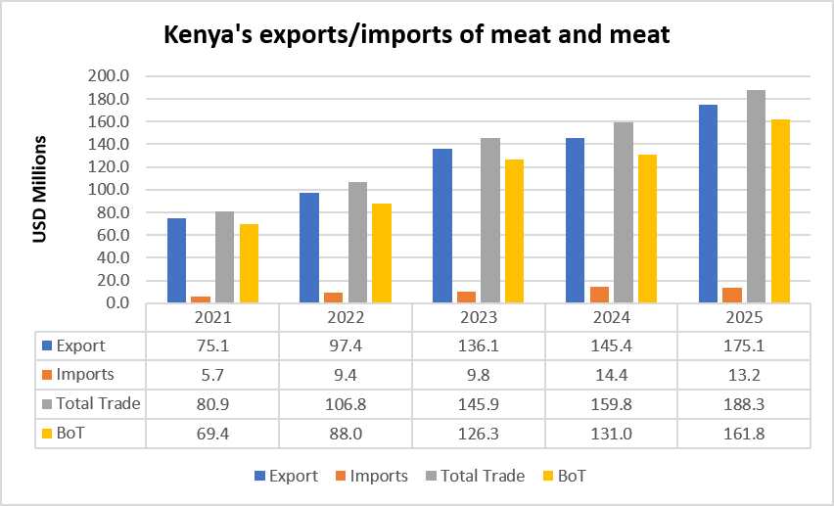
Source: International Trade Centre Trade database
- In 2025, Kenya`s exports of meat and meat were valued at USD 175.1 million in 2025 from USD 145.4 million representing a 20.4% growth.
- Kenya exports more meat and meat has increased significantly from USD 75.1 million in 2021 to USD 175.1 million in 2025. This performance underscores the increasing competitiveness, quality, and international acceptance of Kenyan meat and meat products in regional and global markets.
- Kenya's exports represent 0.1% of world exports for this product
- Kenya’s global ranking in world exports is 51
- At the same time, imports have remained relatively low, increasing modestly from USD 5.7 million in 2021 to USD 13.2 million in 2025. As a result, Kenya maintained a strong and growing trade surplus throughout the review period.
Table 11: Kenya's exports of meat products by country
Source: International Trade Centre Trade database
- Kenya’s lead destination markets in 2025 were; United Arab Emirates (USD 102.5 million; 58.5%), Saudi Arabia (USD 20.9 million; 11.9%), Bahrain (USD 19.1 million; 10.9%), Kuwait (USD 18.1 million; 10.3%) and South Sudan (USD 4.8 million; 2.8%).

Table 12: Kenya's exports of meat products by values
Source: International Trade Centre Trade database
- Kenya’s lead exports of meat products by value in 2025 include: Meat of sheep or goats (USD 161.0 million; 92.0%), Meat of bovine animals, frozen (USD 7.9 million; 4.5%), Meat and edible offal, salted, in brine, dried or smoked; edible flours and meals of meat (USD 2.2 million; 1.3%), Meat of bovine animals, fresh or chilled (USD 2.0 million; 1.1%), and Meat of swine (USD 1.7 million; 1.0%).

Table 13: Kenya's exports of processed meat products by values
Source: International Trade Centre Trade database
- In 2025, Kenya`s exports of processed meat were valued at USD 6.6 million.
- The country’s lead exports of processed meat products by value in 2025 include: Sausages and similar products (USD 6 million; 90.3%), Crustaceans, molluscs and other aquatic invertebrates, prepared or preserved (excl. smoked) (USD 0.6 million, 8.7%), and Prepared or preserved meat, meat offal, blood or insects (excl. sausages and similar products)(USD 0.1 million, 0.8%).

Table 14: Kenya's exports of meat products by quantities (tonnes)
Source: International Trade Centre Trade database
- Kenya’s lead exports of meat products by quantity in 2025 include: Meat of sheep or goats (27.1 million tons; 90.1%), Meat of bovine animals, frozen (1.5 million tons; 4.9%), Meat of swine (0.5 million tons; 1.7%), Meat of bovine animals, fresh or chilled (0.4 million tons; 1.4%), and Meat and edible offal, salted, in brine, dried or smoked; edible flours and meals of meat (0.3 million tons; 1.0%)

Table 15: Kenya's imports of meat products by country
Source: International Trade Centre Trade database
- Kenya’s lead imports of meat products by country in 2024 include: Brazil (USD 5.43 million; 41.1%), Uganda (USD 5.39 million; 40.9%), Germany (USD 0.8 million; 6.3%) and Somalia (USD 0.7 million; 5.2%),

Table 16: Kenya's imports of meat products by values
Source: International Trade Centre Trade database

- Kenya’s lead imports of meat products by value in 2025 include: Meat of swine (USD 6.7 million; 50.6%), Meat and edible offal of fowls of the species Gallus domesticus, ducks, geese, turkeys (USD 5.6 million; 42.8%), Meat of sheep or goats (USD 0.7 million; 5.2%), Meat and edible offal, salted, in brine, dried or smoked; edible flours and meals of meat (USD 0.1 million; 0.6%) and Meat of bovine animals (USD 0.1 million; 0.6%).

Table 17: Kenya's imports of meat products by quantities (tonnes)
Source: International Trade Centre Trade database

- Kenya’s lead imports of meat products by quantity in 2025 include: Meat of swine (2.4 million tons; 53.4%), Meat and edible offal of fowls of the species Gallus domesticus, ducks, geese, turkeys (1.9 million tons; 42.7%), Meat of bovine animals (0.1 million tons; 2.2%), Meat of sheep or goats (0.03 million tons; 0.7%) and Edible offal of bovine animals, swine, sheep, goats, horses, asses, mules or hinnies, fresh (0.02 million tons; 0.5%).

3.1 Kenya’s export potential for meat and meat

Figure 3: Export potential of meat (except poultry)
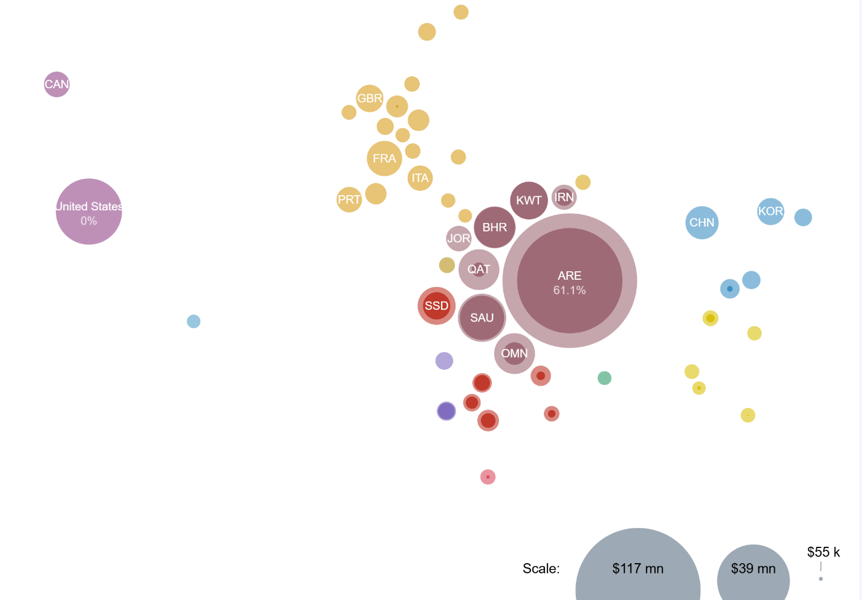
Export Potential Map, 2026
- Kenya’s export potential of meat except poultry is USD 215 million with an Unrealized potential of USD 2.4 million
- The markets with greatest potential for Kenya’s exports of Meat (except poultry) are United Arab Emirates, United States and Saudi Arabia.
- United Arab Emirates shows the largest absolute difference between potential and baseline exports in value terms

Figure 4: Export potential for swine meat, cured, n.e.s.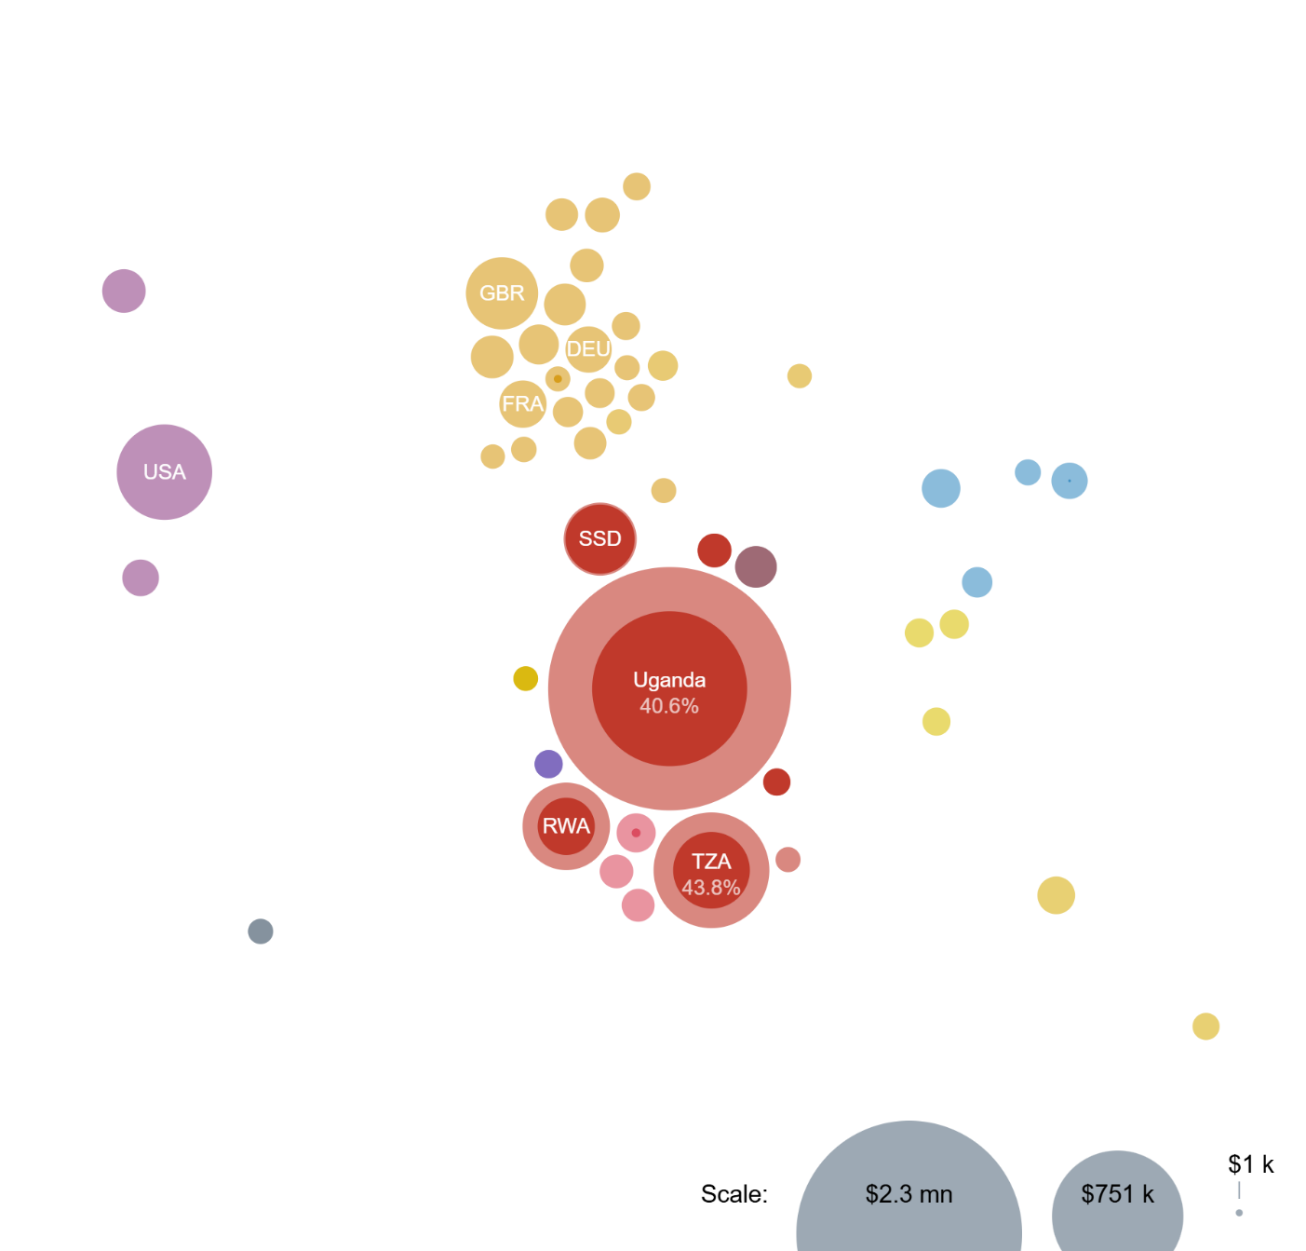
Export Potential Map, 2026

- Kenya’s export potential of swine meat, cured, n.e.s is USD 3.8 million with an Unrealized potential of USD 114 million
- The markets with greatest potential for Kenya’s exports of 021019 Swine meat, cured, n.e.s. are Uganda, Tanzania, United Republic of and United States.
- Uganda shows the largest absolute difference between potential and baseline exports in value terms.
Figure 5: Export potential for processed meat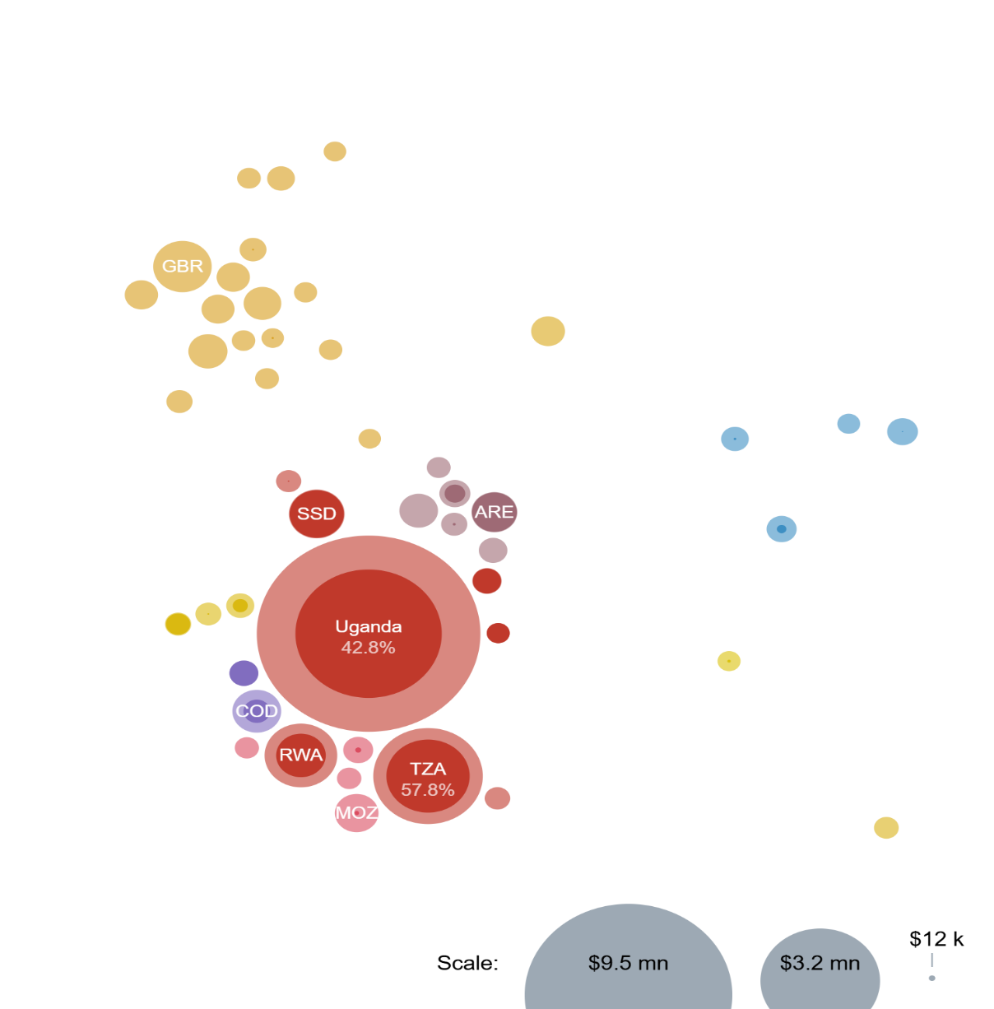
Export Potential Map, 2026

- Kenya’s export potential of processed meat is USD 16 million with an Unrealized potential of USD 9.5 million
- The markets with greatest potential for Kenya’s exports of Processed meat are Uganda, Tanzania, United Republic of and Rwanda.
- Uganda shows the largest absolute difference between potential and baseline exports in value terms

Figure 6:Kenya’s export potential of Meat (poultry)
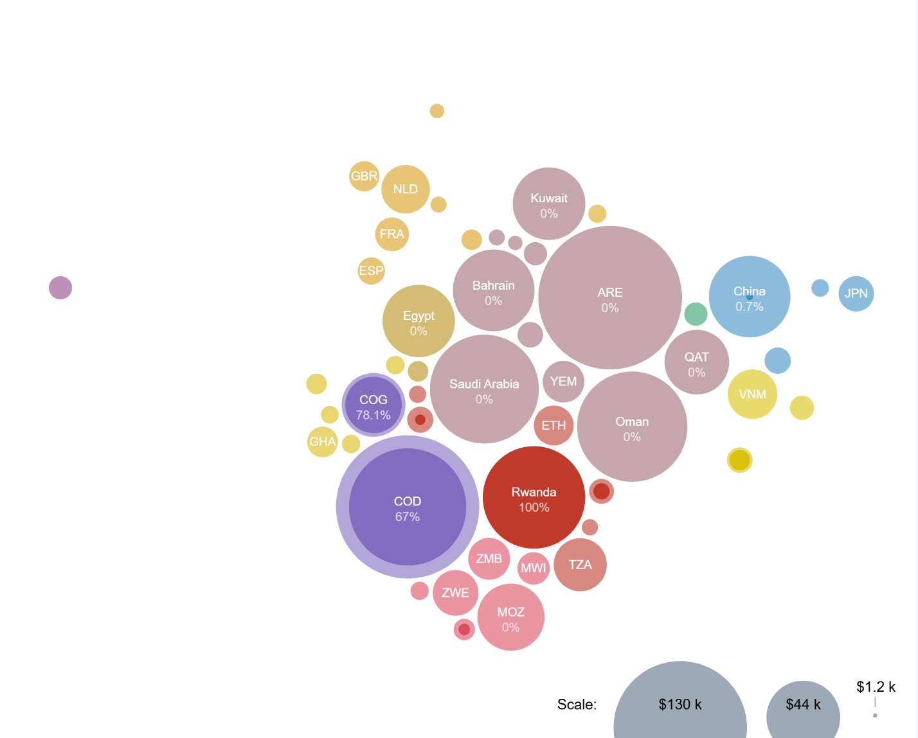
Export Potential Map, 2026

- Kenya’s export potential of Meat (poultry) is USD 925 thousand with an Unrealized potential of USD 746 thousand
- The markets with greatest potential for Kenya’s exports of Meat (poultry) are United Arab Emirates, Congo, Democratic Republic of the and Oman.
- United Arab Emirates shows the largest absolute difference between potential and baseline exports in value terms

4.0 Competitor Analysis for Kenya’s top 5 Export Markets for Meat
Table 18: Competitor Analysis
Source: International Trade Centre Trade database

- Kenya's strongest competitive position is observed in South Sudan, where it is the leading supplier with a market share of 53.4%, while notable footholds have also been established in Bahrain (6.9%), DRC (5.4%), and UAE (3.3%).
- The UAE accounts for approximately 58.5% of Kenya's exports to the analyzed markets, highlighting a significant concentration risk.

5.0 Policy Recommendations
- Strengthen market penetration and exports to the UAE under the Kenya-UAE Comprehensive Economic Partnership Agreement (CEPA).
- Negotiate for improved market access conditions and address non-tariff barriers in the Gulf region.
- Prioritize Saudi Arabia as a strategic growth market, leveraging halal certification and government-to-government engagement.
- Increase exports to South Sudan and DRC by expanding product range and distribution networks under the East African Community framework.
- Invest in meat processing and cold-chain infrastructure to enhance quality and shelf-life.
- Promote Kenya's grass-fed and halal meat branding to differentiate products from major global competitors.

References
TradeMap
Organisation for Economic Co-operation and Development
Food and Agriculture Organization
Economic Survey

